Math 10

Lesson 6-4 Answers

**Lesson Questions**

**Question 1**

A tetrahedron has four congruent triangles. Therefore the surface area is given by



**Question 2**

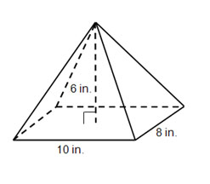

For the rectangular prism the two sides of the base result in two triangular faces with a base of 8 in. and two faces with a base of 10 in. In addition, we are given the height of the prism. We need to calculate the slant height for each triangular face.

For the 8 in. triangle face For the 10 in. triangle face



6

4

*s*10



6

5

*s*8

The surface area of the rectangular pyramid is



**Question 3**

For a right cone



We are given *r* (4 m) and *h* (10 m) so we need to calculate *s* first.

10

4

*s*



We can calculate the surface area:



**Question 4**

Note that the given area (3000 in.2) is for the faces of the pyramid. Therefore, the area of one face is



Using the formula for the area of a triangle





*h*

25

30

**Assignment**

1. a) 151 in.2 b) 2356 cm2

2. a) 896 cm2 b) 628 yd. 2

3. a)

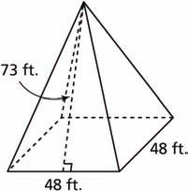

b) 7008 ft. 2

4. 923 285 ft. 2

5. a) 2261.9 cm2 b) $11.94

6. a) 87 m2 b) 176 ft. 2

7. 2.0 m2; I assumed the hides had equal areas.

8. 188 ft. 2

9. a) Right square pyramid and right cone b) Right rectangular prism

10. The Louvre

11. a) 193.7 cm2 b) 34.9 m2

12. 61 ft. 2

13. 16.0 cm